Weekly Agenda 9/12 – 9/16
Brit Lit and Comp – McBride
Mon. 12
- SAT/ACT
- QW – What heroes and villains teach us about human nature?
- Read Part I Beowulf pg.18
- HW – Finish reading Beowulf Part 1, Work on IC
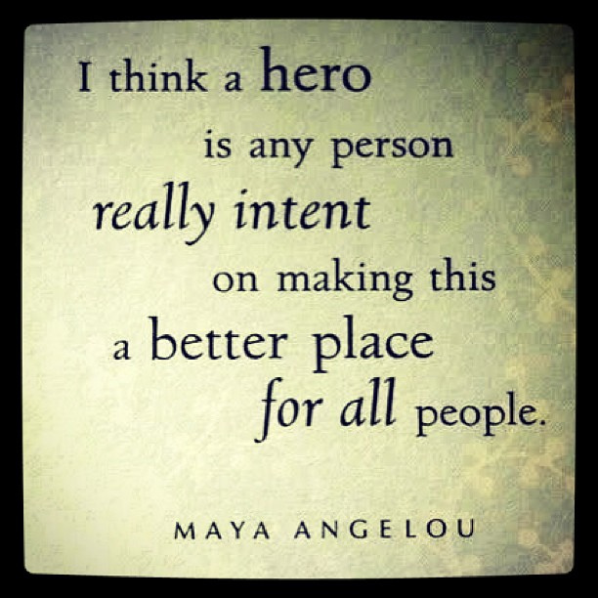
Tues. 13
- ACT/SAT
- Beowulf Part I Reading Check
- Beowulf Part 2 – Gendel’s Mother!
- Track answers on I.C.
- HW – Finish Grendel’s Mother in Lit Book
Wed. 14 -Laptops
- ACT WOTD/SAT QOTD
- Epic Trailhead
- HW - Work on essay revision, due Monday
Thurs. 15 – laptops – Financial Aid Workshop tonight at 7pm!
- ACT/SAT
- Review Argument Essay Rubric
- Essay revision/Conferences
- HW – Work on essay revision, due Monday
Fri.16 - laptops
- ACT/SAT
- Essay revision/Conferences
- HW – Revised Essays due Monday, 9/19!
CCSS.ELA-LITERACY.W.11-12.7
Conduct short as well as more sustained research projects to answer a question (including a self-generated question) or solve a problem; narrow or broaden the inquiry when appropriate; synthesize multiple sources on the subject, demonstrating understanding of the subject under investigation.
CCSS.ELA-LITERACY.W.11-12.2
Write informative/explanatory texts to examine and convey complex ideas, concepts, and information clearly and accurately through the effective selection, organization, and analysis of content.

Weekly Agenda 9/12 – 9/16
Brit Lit and Comp – McBride
Mon. 12
- SAT/ACT
- QW – What heroes and villains teach us about human nature?
- Read Part I Beowulf pg.18
- HW – Finish reading Beowulf Part 1, Work on IC
Tues. 13
- ACT/SAT
- Beowulf Part I Reading Check
- Beowulf Part 2 – Gendel’s Mother!
- Track answers on I.C.
- HW – Finish Grendel’s Mother in Lit Book
Wed. 14 -Laptops
- ACT WOTD/SAT QOTD
- Epic Trailhead
- HW - Work on essay revision, due Monday
Thurs. 15 – laptops – Financial Aid Workshop tonight at 7pm!
- ACT/SAT
- Review Argument Essay Rubric
- Essay revision/Conferences
- HW – Work on essay revision, due Monday
Fri.16 - laptops
- ACT/SAT
- Essay revision/Conferences
- HW – Revised Essays due Monday, 9/19!
CCSS.ELA-LITERACY.W.11-12.7
Conduct short as well as more sustained research projects to answer a question (including a self-generated question) or solve a problem; narrow or broaden the inquiry when appropriate; synthesize multiple sources on the subject, demonstrating understanding of the subject under investigation.
CCSS.ELA-LITERACY.W.11-12.2
Write informative/explanatory texts to examine and convey complex ideas, concepts, and information clearly and accurately through the effective selection, organization, and analysis of content.

